CpE 111 Homework Assignment #9 Maximum – 100pts

HW#9 is due at the beginning of class on May 1, 2006. You must always show or explain your work in a neat and orderly format. You are encouraged to discuss ideas with other students and consult references but your work must be your own.

1. Consider the sequential circuit shown below. In this circuit, p is the input, f is the output, and A is the state variable.

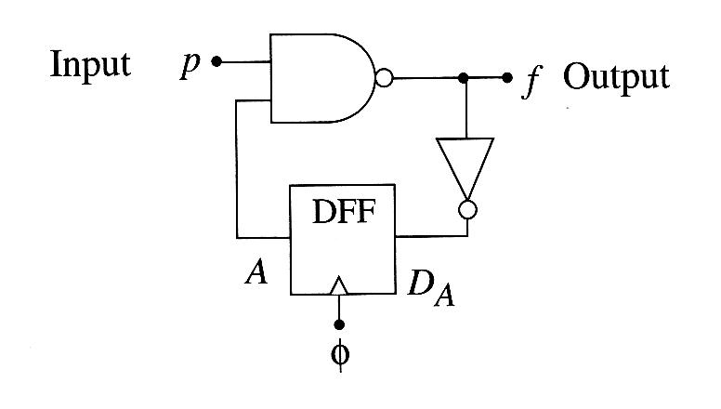
(a) Determine the Boolean equations for f(t) and D_{A}(t).
(b) Construct the state table for the circuit.
(c) Use the state table to draw the state diagram.

2. Consider the sequential circuit shown below. Suppose that the XOR2 gate is replaced by an OR2 gate, but everything else remains the same.

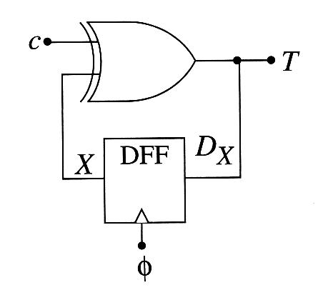
(a) Construct the state table for the modified circuit.
(b) Create the state diagram from the state table.

3. Construct the state diagram for the system described in the state table shown below. Note that x is the input, and A and B are the state variables.

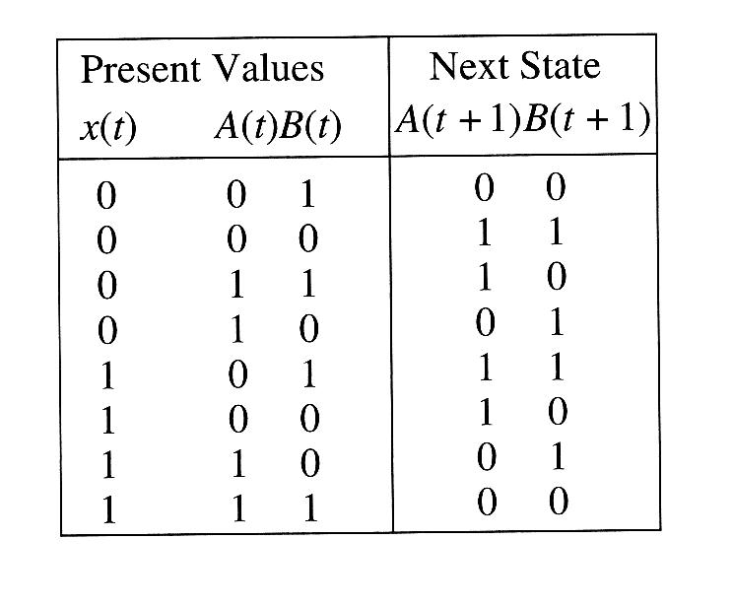

4. Consider the given state diagram below. (15pts)

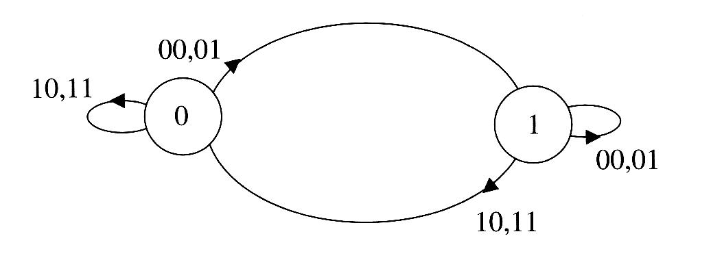

(a) Construct the state table for the network described by the state diagram. Denote the state variable as Q and the input word as d₁d₀.
(b) Design the circuit diagram using the information from your state table.

5. Consider a 4-bit binary counter that increments on every clock pulse. (20pts)

(a) Construct the state diagram for a counter that has an state variable word A₃A₂A₁A₀.
(b) Construct the state table by assuming that the circuit consists of four D-type flip-flops with the inputs D₃, D₂, D₁, D₀ corresponding to the outputs A₃, A₂, A₁, A₀, respectively.
(c) Determine the Boolean equations for the flip-flop inputs as functions of the state variables A₃, A₂, A₁, A₀, respectively.
(d) Design the PLA-based circuit diagram for this counter.

6. Consider the sequential logic circuit shown below. (15pts

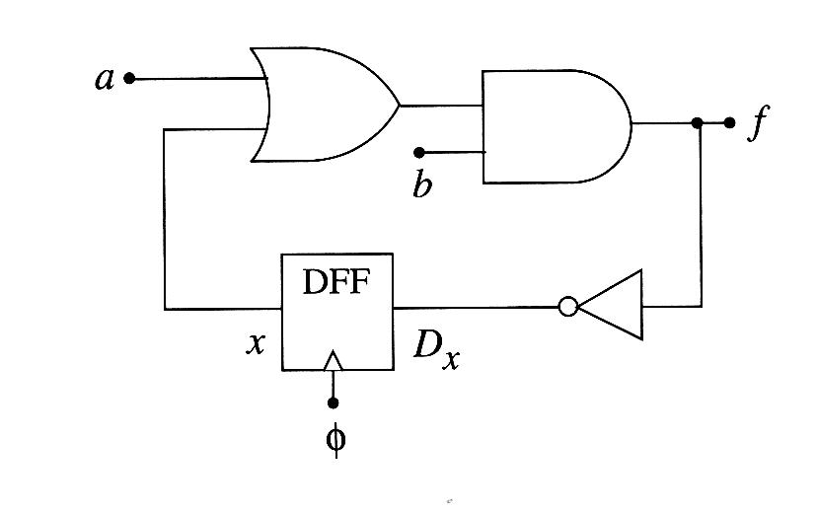
(a) Construct the state table.
(b) Construct the state diagram.

7. Consider the four-state sequential circuit shown below. Evaluate the circuit and then construct the state table and state diagram that describe its operation. (20pts)

